**Diagrams**

1. **Sequence Diagram**:
   * The user starts the application, initializing the Raspberry Pi and camera.
   * The camera continuously captures frames, which are sent to the emotion detection model.
   * Detected emotions are used to query the YouTube API for music recommendations.
   * Recommendations and detected emotions are displayed on the screen.
   * The user can stop the application, terminating the video stream.
2. **sequenceDiagram**
3. participant User
4. participant RaspberryPi
5. participant Camera
6. participant EmotionModel as Emotion Detection Model
7. participant YouTubeAPI as YouTube Data API
8. participant Screen as Display Screen
9. User**->>**RaspberryPi: Start the application
10. RaspberryPi**->>**Camera: Initialize camera and start video stream
11. **loop** Continuous Process
12. Camera**-->>**RaspberryPi: Capture video frame
13. RaspberryPi**->>**EmotionModel: Detect faces and predict emotions
14. EmotionModel**-->>**RaspberryPi: Return detected emotions
15. RaspberryPi**->>**YouTubeAPI: Fetch music recommendations based on emotion
16. YouTubeAPI**-->>**RaspberryPi: Return music recommendations
17. RaspberryPi**->>**Screen: Display detected emotion and recommendations
18. **end**
19. User**->>**RaspberryPi: Stop the application
20. RaspberryPi**->>**Camera: Stop video stream

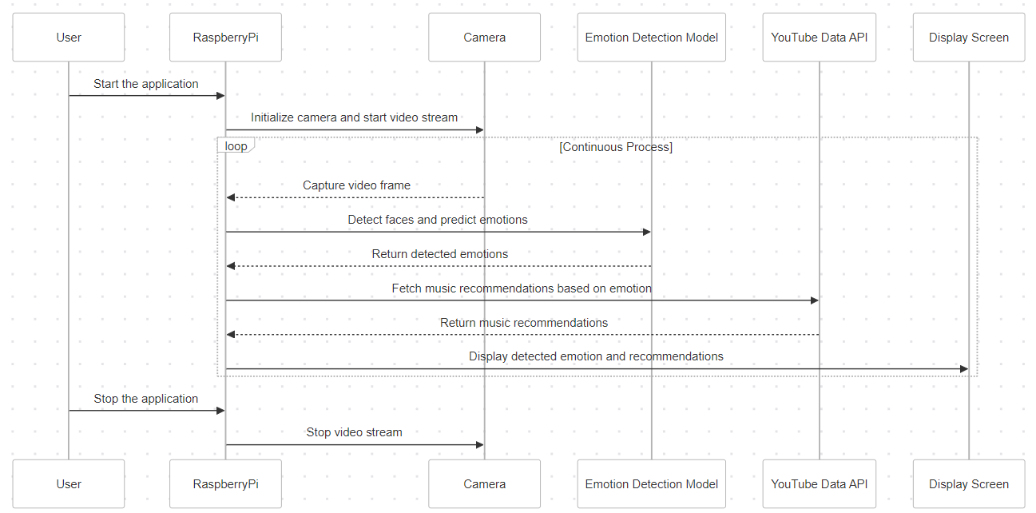

1. **Data Flow Diagram**:
   * The application starts with the initialization of components.
   * Frames are captured from the camera and preprocessed.
   * Face detection is performed, and if a face is found, it is sent to the emotion detection model.
   * Based on the detected emotion, the YouTube API is queried for music recommendations.
   * Results are displayed on the screen, and the loop continues until the application is stopped.
2. **graph** TD
3. A[Start Application] **-->** B[Initialize Raspberry Pi and Components]
4. B **-->** C[Capture Video Frame from Camera]
5. C **-->** D[Preprocess Frame: Convert to Grayscale and Resize]
6. D **-->** E[Face Detection with OpenCV]
7. E **-->**|Face Detected| F[Predict Emotion using Detection Model]
8. F **-->**|Detected Emotion| G[Query YouTube API for Music Recommendations]
9. G **-->**|Recommendations| H[Display Emotion and Music on Screen]
10. H **-->** I{Continue Capturing Frames?}
11. I **-->**|Yes| C
12. I **-->**|No| J[Stop Camera and Exit Application]

